Ch3: Generalized inverse, individual activity

Hang Chen

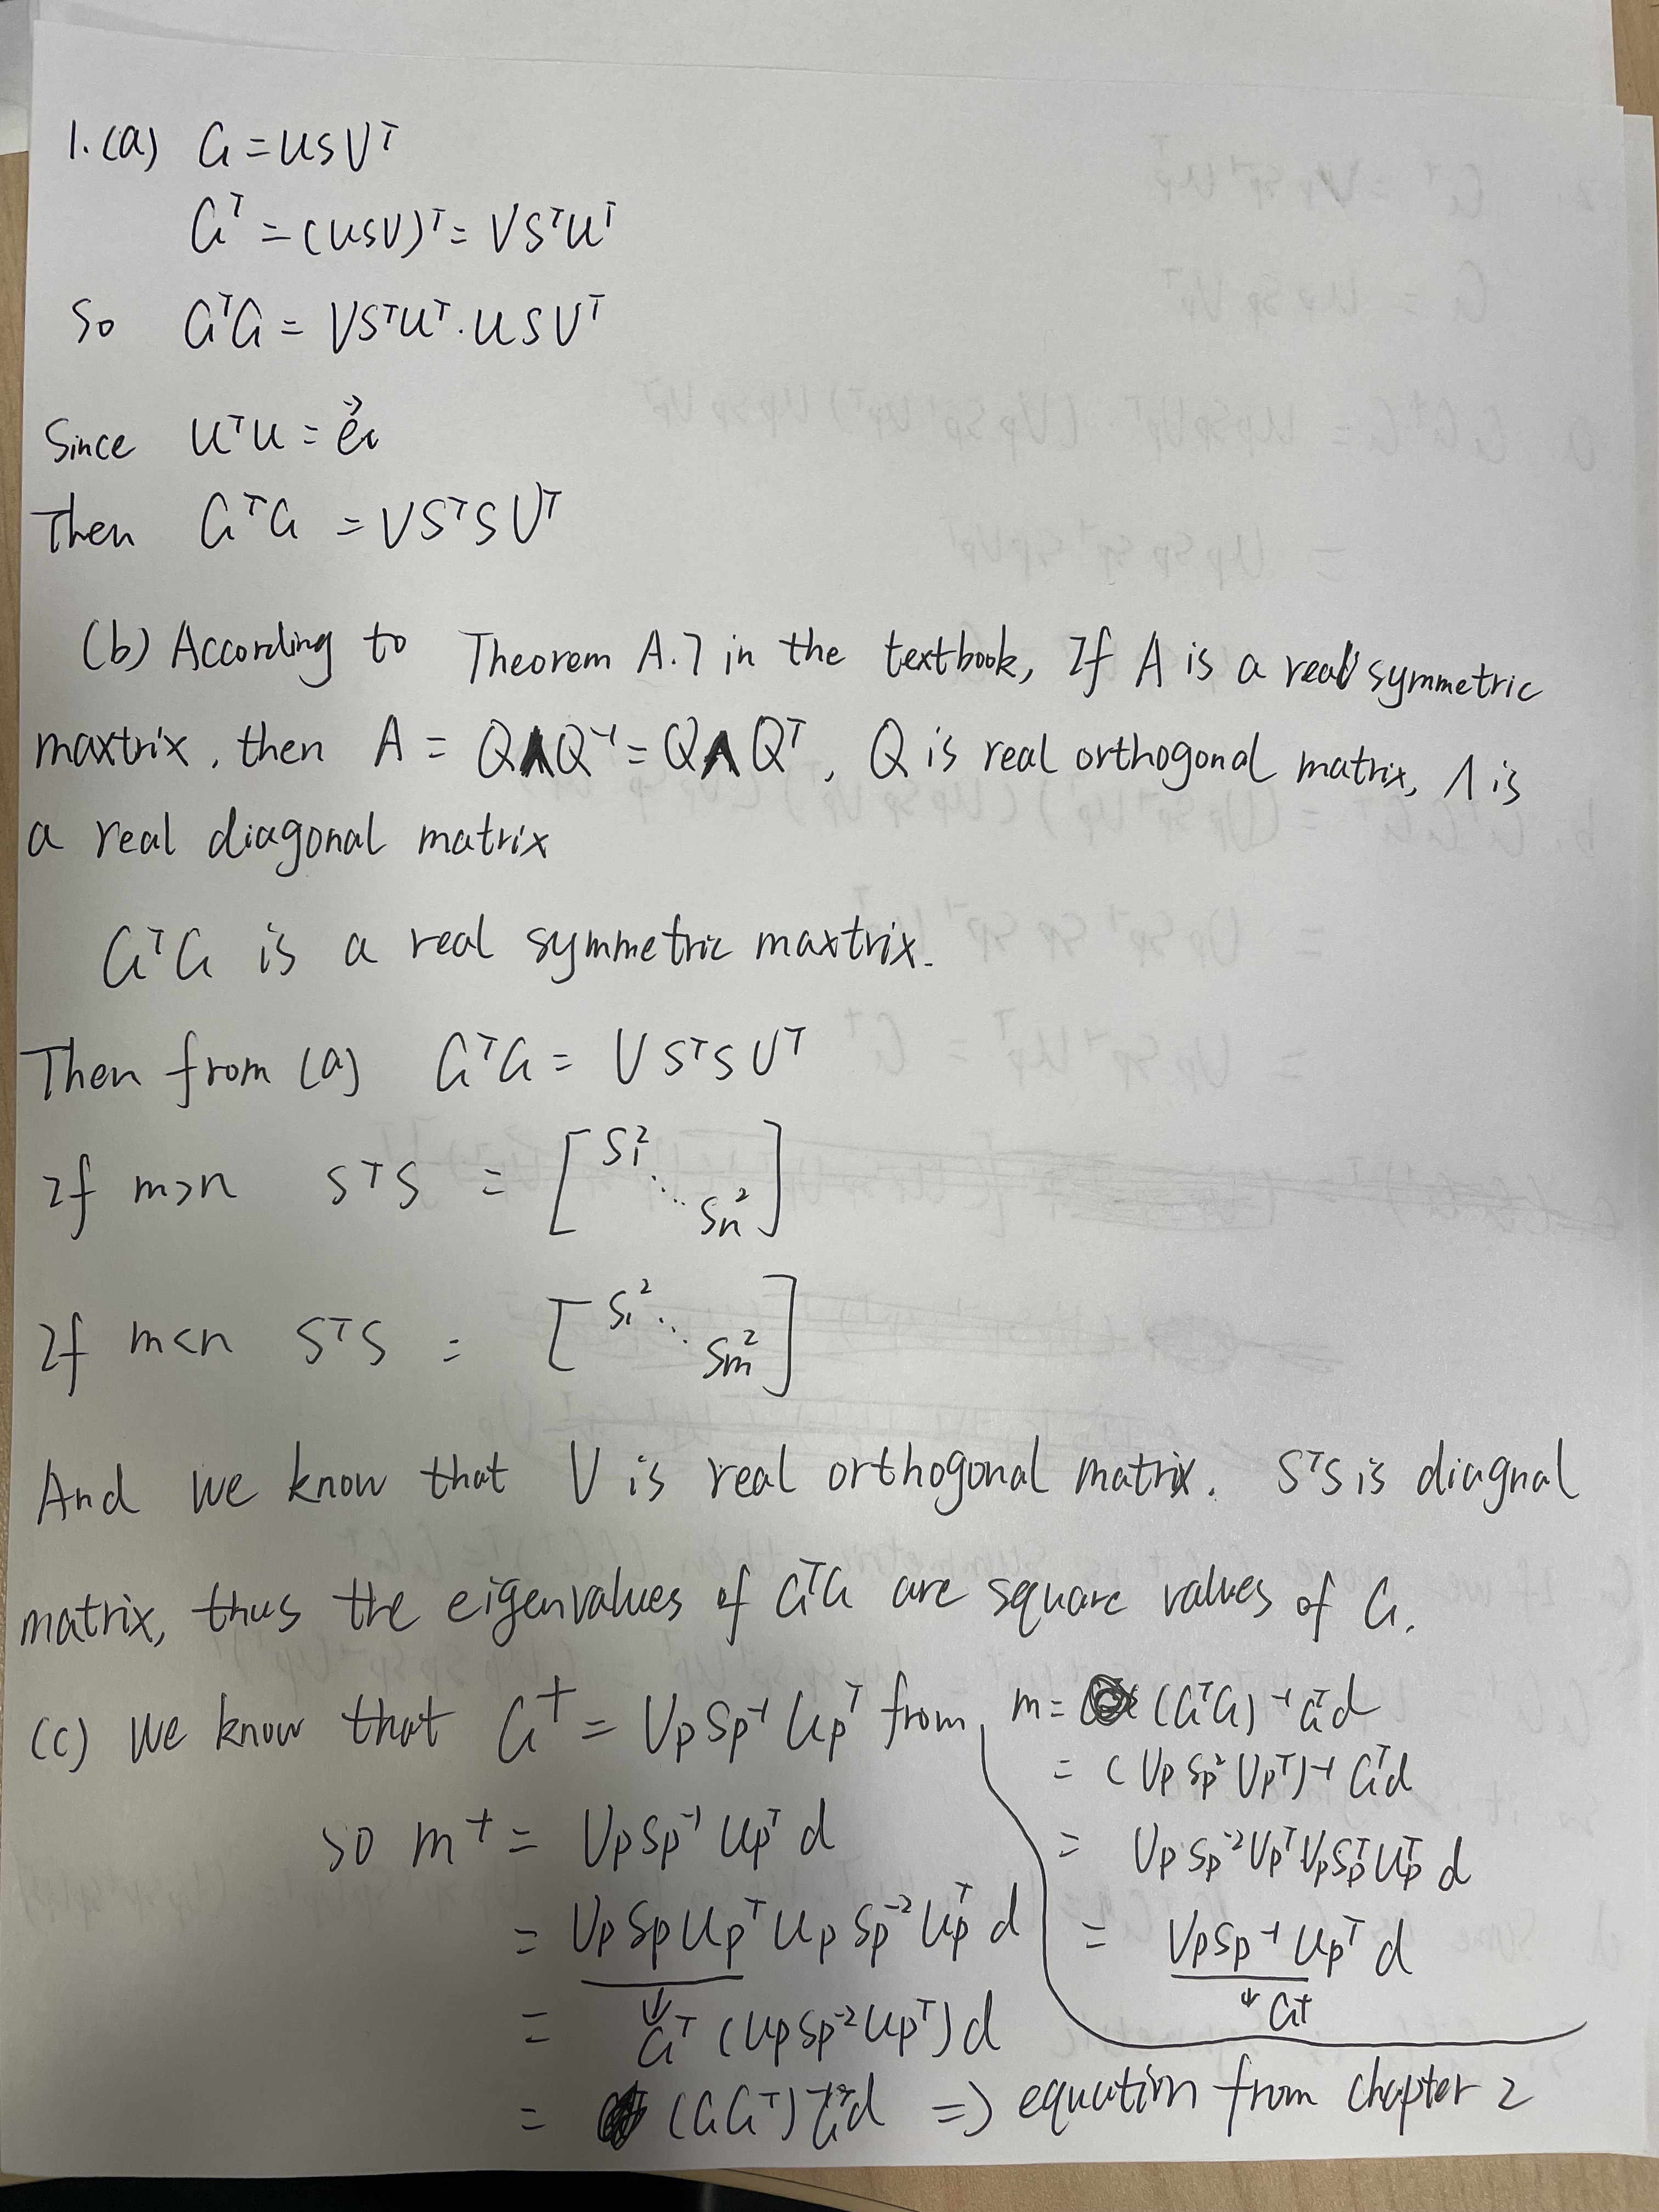

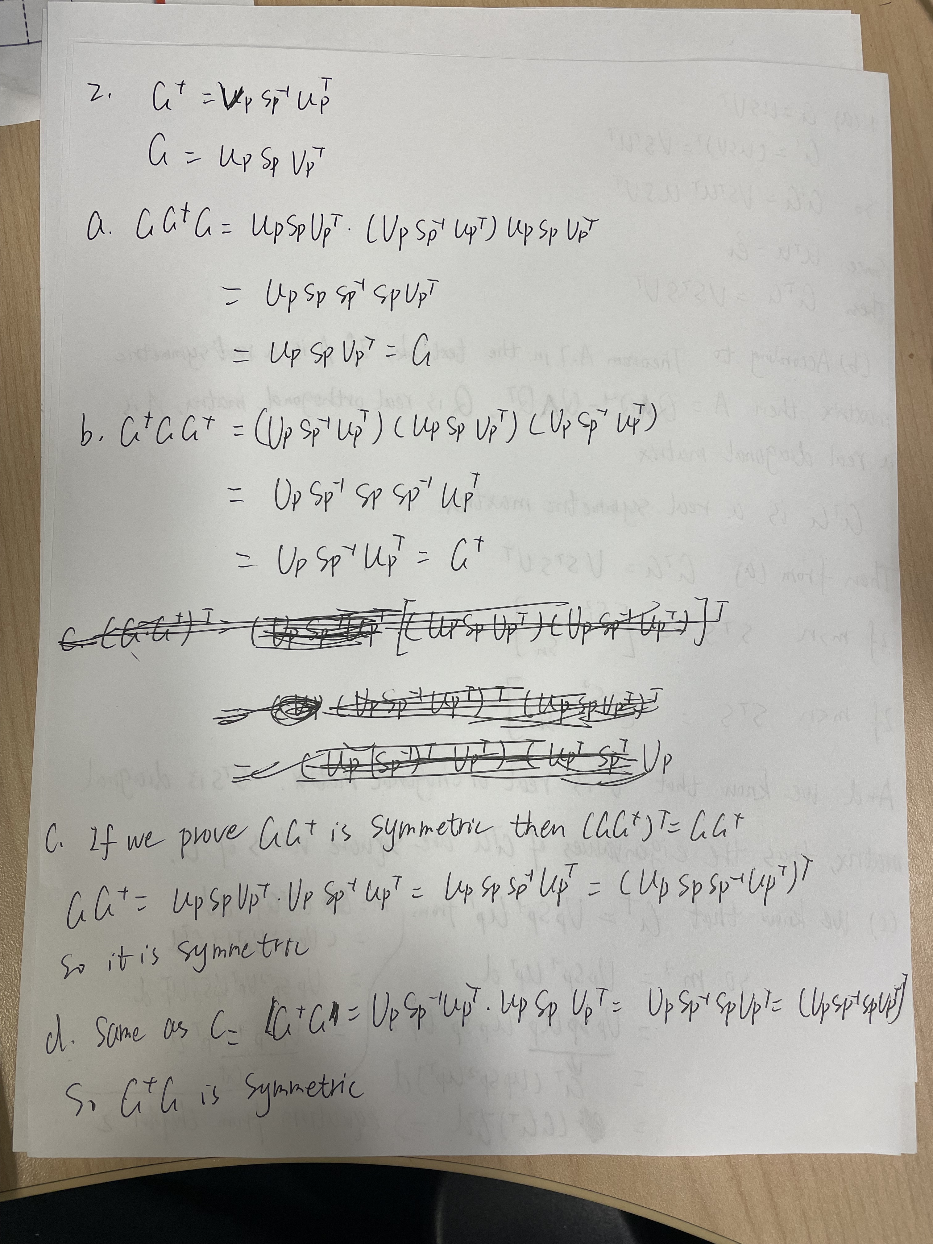

Question 3

(a)

m =

-3.68867239266073e-07

-8.69669914110091e-06

1.39889971370030e-06

3.03300858899103e-07

-6.70220057259940e-06

2.73223304703363e-06

9.73223304703364e-06

2.06556638036697e-06

3.53553390593274e-06

(b)

m =

-7.02200572599404e-07

-6.96446609406727e-06

0

-1.42893218813453e-06

-6.36886723926607e-06

4.13113276073393e-06

1.17977994274006e-05

0

3.53553390593274e-06

The comparison of model parameters and predicted data are shown in next page. We can find that the model parameters are slightly different from two methods but the predicted data is exactly the same.





(b) The dimension of the data null space is the 8 – 7 (rank of the G) = 1 but with 8 elements i.e., 8\*1. The vector is shown as



(c) The model null space is 9 - 7 (rank of the G) = 2 with 9 elements i.e., 9\*2. They are shown as



(d) Yes, it is possible, because G is not full rank and inverse solution is not unique. Like the solution to this question in (a)

(e) No, it is impossible. G is unique so if we give a specific m then will be specific Gm.

Codes

%

clear

clc

%% question 3 (a)

% Construct system matrix for the ray path models

s2=sqrt(2);

G = [1,0,0,1,0,0,1,0,0;

0,1,0,0,1,0,0,1,0;

0,0,1,0,0,1,0,0,1;

1,1,1,0,0,0,0,0,0;

0,0,0,1,1,1,0,0,0;

0,0,0,0,0,0,1,1,1;

s2,0,0,0,s2,0,0,0,s2;

0,0,0,0,0,0,0,0,s2];

t = [6e-06,-1.7e-05,4e-06,-4e-06,0,1.9e-05,-5e-06,5e-06].';

% Find and display system rank

p=rank(G);

% for question i

[U,S,V] = svd(G);

Up = U(:,1:p);

temp = diag(S);

Sp = diag(temp(1:p));

Vp = V(:,1:p);

m = Vp\*Sp^-1\*Up'\*t;

% for question ii

m2 = G\t;

figure

subplot(1,2,1)

colormap('gray')

imagesc(reshape(m,3,3))

caxis([min([m;m2]),max([m;m2])]);

set(colorbar,'Fontsize',18);

set(gca,'xtick',[1,2,3,4,5,6,7,8,9]);

set(gca,'ytick',[1,2,3,4,5,6,7,8,9]);

xlabel('j')

ylabel('i')

title('Estimation from generalized inverse of G')

set(gca,'fontsize',14)

subplot(1,2,2)

colormap('gray')

imagesc(reshape(m2,3,3))

caxis([min([m;m2]),max([m;m2])]);

set(colorbar,'Fontsize',18);

set(gca,'xtick',[1,2,3,4,5,6,7,8,9]);

set(gca,'ytick',[1,2,3,4,5,6,7,8,9]);

xlabel('j')

ylabel('i')

title('Estimation from backslash operator in MATLAB')

set(gca,'fontsize',14)

figure

plot(t,'o','MarkerSize',8)

hold on

plot(G\*m,'LineWidth',1.5)

hold on

plot(G\*m2,'LineWidth',1.5)

xlabel('Distance (m)')

legend('Observed','Predicted from generalized inverse of G', ...

'Predicted from backslash operator in MATLAB')

ylabel('Time (s)')

set(gca,'fontsize',14)

%% Question 3 (b)

% Display data space null vector

disp('Data null space vector')

U(:,p+1)

figure

imagesc(U(:,p+1))

set(gca,'ytick',[1,2,3,4,5,6,7,8]);

set(colorbar,'Fontsize',18);

set(gca,'fontsize',14)

%% Question (c)

% Display null space vectors reshaped to match tomography example geometry

disp('Model null space vectors reshaped into matrices')

m01=reshape(V(:,p+1),3,3)'

m02=reshape(V(:,p+2),3,3)'

figure

subplot(1,2,1)

colormap('gray')

imagesc(m01)

caxis([-0.5 0.5]);

set(colorbar,'Fontsize',18);

set(gca,'xtick',[1,2,3]);

set(gca,'ytick',[1,2,3]);

xlabel('j')

ylabel('i')

set(gca,'fontsize',14)

title('Reshaped Null Space Model V.,8');

subplot(1,2,2)

colormap('gray')

imagesc(m02)

caxis([-0.5 0.5]);

set(colorbar,'Fontsize',18);

set(gca,'xtick',[1,2,3]);

set(gca,'ytick',[1,2,3]);

xlabel('j')

ylabel('i')

title('Reshaped Null Space Model V.,9');

set(gca,'fontsize',14)